**Assignment No.04**

**Name:-** Omprakash Khawshi

***************************************************************************

**Q.1 Write a program in the following steps**

**a. Generates 10 Random 3 Digit number.**

**b. Store this random numbers into a array.**

**c. Then find the 2nd largest and the 2nd smallest element without sorting the array.**

**Code: -**

#!/bin/bash

for((i=0 ;i<11;i++))

do

random=$((100 + RANDOM%20))

num[$i]=$random

done

echo "Array Elements :-" ${num[@]}

temp=0

for (( i=0; i<11; i++))

do

for ((j=i+1; j<11 ; j++))

do

if [ ${num[i]} -gt ${num[$((j))]} ]

then

temp=${num[i]}

num[$i]=${num[$((j))]}

num[$((j))]=$temp

fi

done

done

##echo "Array After Sorting :- { ${num[@]} }"

echo "Second Smallest :- ${num[1]}"

echo "Second Largest :- ${num[9]}"

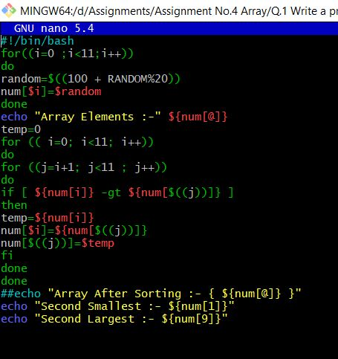

**Output**: -

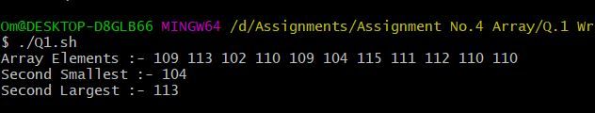

**Q.2 Extend the above program to sort the array and then find the 2nd largest and the 2nd smallest element.**

**Code: -**

#!/bin/bash

for((i=0 ;i<11;i++))

do

random=$((100 + RANDOM%20))

num[$i]=$random

done

echo "Array Before Sorting :- { ${num[@]} }"

temp=0

for (( i=0; i<11; i++))

do

for ((j=i+1; j<11 ; j++))

do

if [ ${num[i]} -gt ${num[$((j))]} ]

then

temp=${num[i]}

num[$i]=${num[$((j))]}

num[$((j))]=$temp

fi

done

done

echo "Array After Sorting :- { ${num[@]} }"

echo "Second Smallest :- ${num[1]}"

echo "Second Largest :- ${num[9]}"

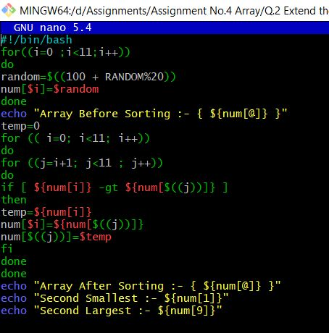

**Output: -**

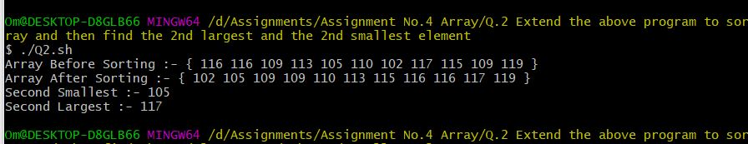

**Q.3 Extend the Prime Factorization Program to store all the Prime Factors of a number n into an array and finally display the output.**

**Code: -**

echo "enter an integer:"

read input

i=2

count=0

flag=0

for ((i;i<$input;));do

if [ `expr $input % $i` -eq 0 ];then

factor=$i

for ((j=2;j<=`expr $factor / 2`;));do

flag=0

if [ `expr $factor % $j` -eq 0 ];then

flag=1

break

fi

j=`expr $j + 1`

done

if [ $flag -eq 0 ];then

nos=$factor

array[$i]=$nos

count=1

fi

fi

i=`expr $i + 1`

done

if [ $count -eq 0 ];then

echo "no prime factors found except 1 and $input"

fi

echo ${array[@]}

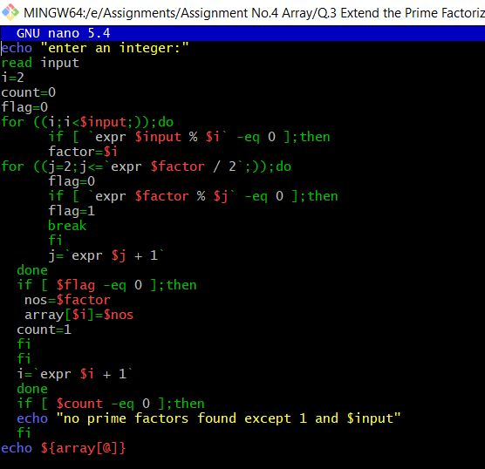

**Output:-**

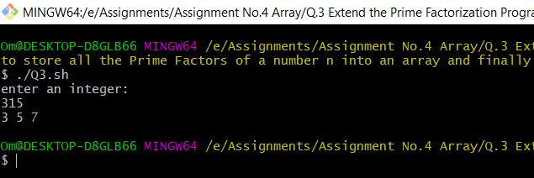

**Q.4 Write a Program to show Sum of three Integer adds to ZERO**

**Code: -**

function tsfz()

{

echo " ☃☃☃ Array Elements which have Addition is Zero ☃☃☃"

for (( i=0 ; i<$(($n-2)) ; i++ ))

do

for (( j=$(($i+1)) ; j<$(($n-1)) ; j++ ))

do

for (( k=$(($i+2)) ; k<$n ; k++ ))

do

a=$(( ${arr[$i]} + ${arr[$j]} + ${arr[$k]} ))

if(($a==0))

then

echo "(${arr[$i]},${arr[$j]},${arr[$k]})"

found=1

fi

done

done

done

if(( $found==0 ))

then

echo "☹☹☹ No Elements find Addition is Zero ☹☹☹ "

fi

}

arr=(0 -1 2 -3 1 1 -2 1 0 5 )

n=${#arr[@]}

tsfz $arr $n

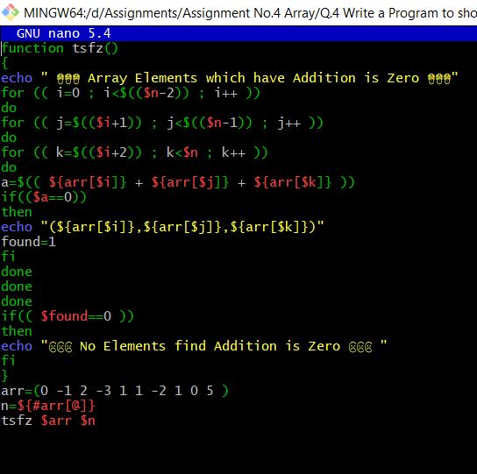

**Output: -**

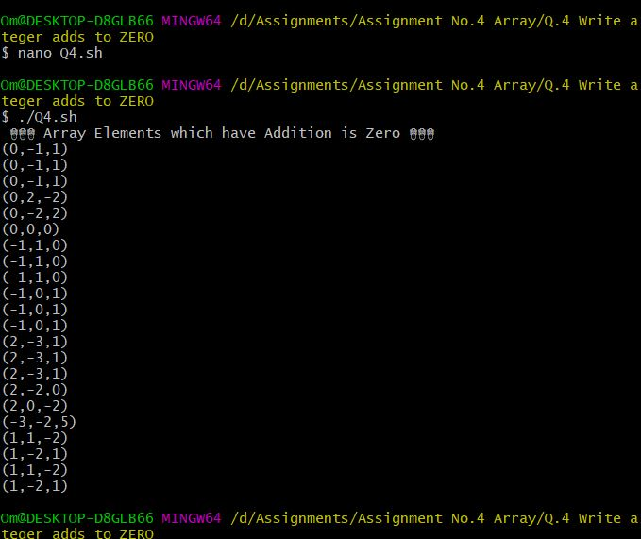

**Q.5 Take a range from 0 – 100, find the digits that are repeated twice like 33, 77, etc and store them in an array**

**Code: -**

flag=1

arr=()

for i in $(seq 100)

do

Number_1=$i

Number_2=$(( $Number_1%10 ))

Number_3=$(( $Number_1/10 ))

if [ $Number_2 == $Number_3 ]

then

Number_4=$Number_1

arr[$Number_1]=$Number_4

fi

done

echo "{ ${arr[*]} }"

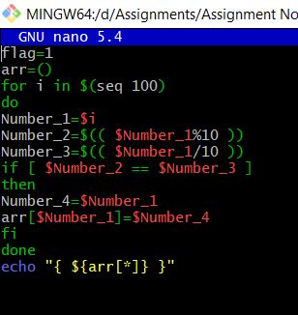

**Output: -**

